Design and implementation of a patch-fractal antenna with phase control using Butler matrix

Diseño e implementación de una antena parche-fractal con control de fase utilizando la matriz de Butler
Chuquimarca Joel, Orellana Ariel, Chamba Fabian, Badillo Xavier, and Leon Cristian
Abstract— The study presents the successful design and implementation of a phase-controlled patch-fractal antenna using the Butler array. This work focuses on developing a laboratory prototype of a 4x4 array using microstrip technology. Theoretical conditions are established, and the theoretical basis of the microwave circuits that make up the matrix is described. Each element is individually designed, optimized, and simulated using specialized software (Ansoft Designer and Advanced Design System), and then its performance is verified by evaluating functional parameters. The tested designs are integrated into a single circuit to form the Butler matrix and are subjected to simulation and optimization before manufacturing. The functionality of the components is verified using a vector network analyzer. An analysis of the discrepancy between the measured values and the theoretical target parameters is performed, providing a comprehensive evaluation of the prototype's performance. Implementing the 4x4 Butler matrix together with the design of patch-fractal microstrip antennas has allowed practical phase control, demonstrating its viability in various applications. Results from both simulation and laboratory tests support the ability to direct the radiation lobe in various areas without the need for additional mechanical structures. The applicability of this antenna in short-range radar systems is highlighted, offering flexibility in addressing without compromising essential electromagnetic properties. For future applications requiring more precise control with a more significant number of radiation lobes, a Butler array with more ports is suggested.

Index Terms— Butler matrix, Patch-fractal antenna, Micro-strip, Microwave.

Resumen—El estudio presenta el diseño y la implementación exitosos de una antena parche-fractal con control de fase utilizando la matriz de Butler, una técnica fundamental para la formación de haces múltiples en antenas. El proyecto se enfoca en desarrollar un prototipo de laboratorio de una matriz de 4x4 mediante tecnología de microcinta. Se establecen condiciones teóricas y se describe la base teórica de los circuitos de microondas que conforman la matriz. Cada elemento se diseña, optimiza y simula individualmente utilizando software especializado (Ansoft Designer y Advans Design System), luego se verifica su desempeño mediante la evaluación de parámetros funcionales. Los diseños probados se integran en un único circuito para formar la matriz de Butler, la cual es sometida nuevamente a simulación y optimización antes de su fabricación. La funcionalidad de los componentes se verifica mediante un analizador vectorial de redes. Se realiza un análisis de la discrepancia entre los valores medidos y los parámetros teóricos establecidos como objetivo, lo que proporciona una evaluación exhaustiva del rendimiento del prototipo. La implementación de la matriz de Butler de 4x4 junto con el diseño de antenas parche-fractal microstrip ha permitido un control efectivo de la fase, demostrando su viabilidad en diversas aplicaciones. Los resultados tanto de simulación como de pruebas de laboratorio respaldan la capacidad de direccionar el lóbulo de radiación en diversas zonas sin necesidad de estructuras mecánicas adicionales. Se destaca la aplicabilidad de esta antena en sistemas radar de corto alcance, ofreciendo flexibilidad en el direccionamiento sin comprometer las propiedades electromagnéticas esenciales. Para futuras aplicaciones que requieran un control más preciso con un mayor número de lóbulos de radiación, se sugiere considerar el uso de una matriz de Butler con un mayor número de puertos.

Palabras Claves—Matriz de Butler, Antena parche-fractal, Microstrip, Microondas.

Introduction
E
ROM Marconi's discoveries from the 1910s until 1929, experiments were carried out involving radiating elements such as monopoles or verticals that were configured to form a parabolic reflector. These experiments were carried out with frequencies within the UHF band and significantly high powers. With the invention of the triode, radio broadcasting began to develop, and it was marked by daily music broadcasts in New Rochelle, New York. Additionally, antennas were built for communications, deployed for navigation assistance, and used in object detection systems. During World War II, notable progress was evident in developing microwave antenna technology for radar applications. New elements such as waveguide openings, reflectors, lenses, and horns were incorporated. Among the most significant contributions were microwave generators, such as the magnetron and the Klystron, which operated at frequencies above 1 GHz [1].
Slots, spirals, and dipoles stood out in the 1950s. Various antennas were developed, including the slotted cylinder, the dipole-slot antenna, the Orr box loop, slots on the aircraft fuselage, circular slots, and the propeller antenna, all of which are characterized by their broadband capacity [1], [2].
Computer technology and architecture expanded from the 1960s to the 1990s, significantly impacting modern antenna theory. During the seventies, the analysis of complex configurations of antenna systems began through numerical methods [1], [3]. The introduction of computers in calculations led to the development of techniques such as the Fast Fourier Transform (FFT), the Geometric Theory of Diffraction (GTD), the Plane Wave Angular Spectrum (PWS), and the Method of Moments.
Multibeam antennas are widely used in wireless communications to improve channel capacity and transmission quality [4], [5]. Various ways of implementing them are based on the grouping of antennas and the variation of the phase of the feed current for each element, the basic principle of electronic phase scanning [1]. In the specialized literature, alternatives have been proposed to simplify the complexity of electronic circuits, including passive circuits such as the Butler matrix, the Blass matrix, Luneberg lenses, and Rotman lenses [6], [7]. Butler (1961) introduced a passive circuit that facilitates beamforming in an antenna array, and the Butler array has gained preference as a commercially viable solution for building multi-beam antennas, according to studies such as Zulkifli, Chasanah, Basari, and Rahardjo (2015). Its continued development has been supported by recent research, such as the advances reported by Tian, Yang, and Wu (2014) and Messaoudene, Youssouf, Bilal, Belazzoug, and Aidel (2017) [8], [9].
The characteristics and operating parameters of the created devices are established through research, including a Butler array and a patch-fractal microstrip antenna array using a frequency of 3 GHz in the S-band. After completing the design and adaptation, preliminary results are generated through simulations, which will later be compared with those obtained in laboratory tests using the corresponding equipment. Programs such as ADS (Advanced Design System) and Ansoft Designer SV are used to design and simulate. Once the simulation results have been evaluated, the practical implementation proceeds, followed by laboratory tests with the prototype to evaluate its performance compared to the simulated results.

Methodology
For the design of this device, it is necessary to separately design its characteristics components, these being the 90° quadrature coupler, the 45° phase switch, and the crossover that serves to join all the mentioned components.

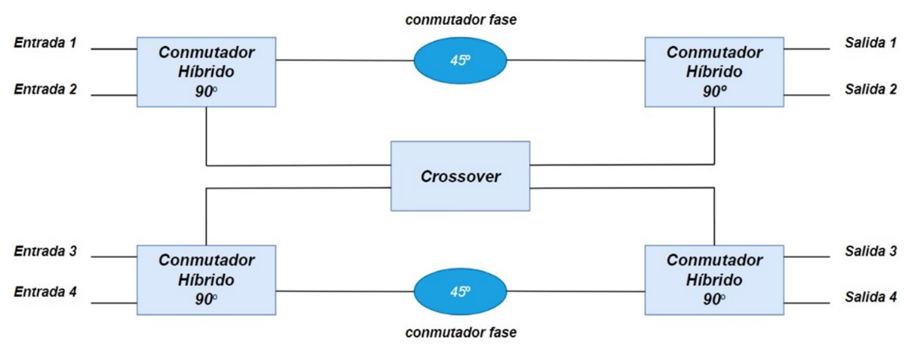
- Butler matrix structure.
Fig. 1 shows the schematic of a 4x4 Butler matrix, along with the elements necessary for its correct operation. Next, the component construction process and the device's simulation and implementation will be explained in detail.
The first step calculates the width dimensions of the transmission lines used to manufacture the Butler array components. These lines must have an impedance of 50 Ω, and the characteristics of the substrate are considered. In this case, the substrate is double-sided Bakelite with a relative permittivity of 4.8 and a substrate height (h) of 1.6 mm. The calculator available in the Ansoft Designer program is used to obtain these values. This tool allows you to enter the desired impedance and returns the required transmission line thickness, as illustrated in Fig. 2.

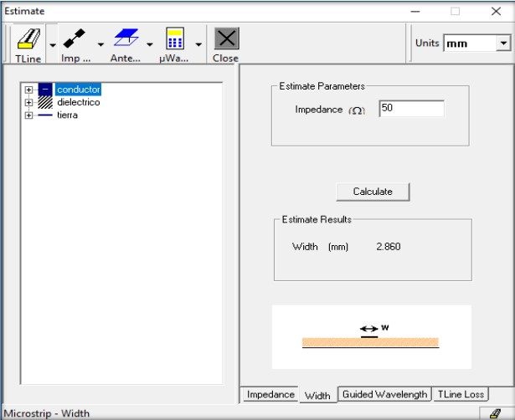
- Calculation of dimensions for the 50 Ω transmission line.
For this project, a type of quadrature hybrid coupler known as a two-section Branchline has been selected. A modified version of this initial design has been developed to improve its performance. The necessary number of 90° Couplers is determined to configure a 4x4 Butler matrix (N = 4). Subsequently, according to the equation, the lambda value is calculated to determine the dimensions of the Branch-line hybrid coupler, illustrated in detail in Fig. 3, along with its dimensions and basic structure.
where ε_{reff} is the effective dielectric constant, ε_{r} is the relative permittivity, d is the substrate height, W is the radiator patch width, λ_{o} is the wavelength in vacuum, C is the speed of light, f is the frequency, and λ is the wavelength.
Based on the design previously developed in [3], the aim is to improve the results and expand the bandwidth. Modified sections have been implemented to expand the operating range and reduce the area required for deployment.

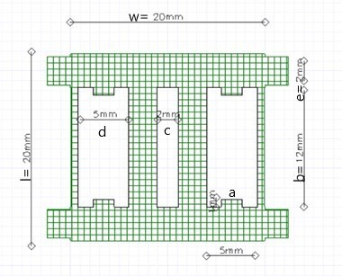
- Two-section branch-line hybrid coupler.
Furthermore, including sections of open microstrip lines, known as stubs, helps eliminate harmonics generated by transmission lines and minimize losses [8]. Fig. 4 shows the design of the quadrature hybrid coupler with the necessary dimensions to meet the established operating requirements.

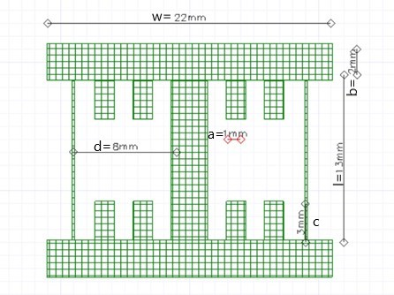
- Modified two-section branch-line hybrid coupler.
A calculation is necessary to determine the number of phase switches required, considering that the value of N represents the number of ports required for the Butler matrix [10]. In this scenario, since the number of inputs and outputs of the matrix N = 4, it is concluded that two crossovers are needed in the configuration.
One of the most recognized designs, the Schiffman phase shifter, describes the dimensions of the switch in its most basic form. With the modified proposal, the 45° phase switch consists of a series of Schiffman phase shifters coupled, which reduces the size of the standard coupler and optimizes the implementation space [1], [11]. This allows accurate and condensed results to be obtained efficiently, as shown in Fig. 5.

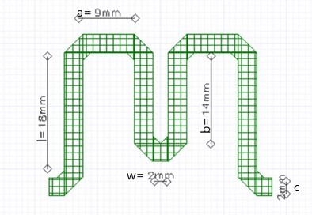
- Modified and synthesized phase switch.
The crosser connects the elements of the Butler matrix. This four-port device transfers the input signal from port 1 to port 3 and port 4 to port 2, crossing the signals with an output phase shift of 0° [12]. Its structure is achieved by connecting two 90° hybrid couplers in series. As in the design of the hybrid coupler, a modified version is implemented to suppress harmonics, reduce losses, and minimize the implementation area, as shown in Fig. 6. This modification involves reducing the dimensions of the hybrid's arms, the increase in the amplitude of the intermediate and lateral transmission lines, as well as the incorporation of open circuit transmission lines in each section of the crossover.

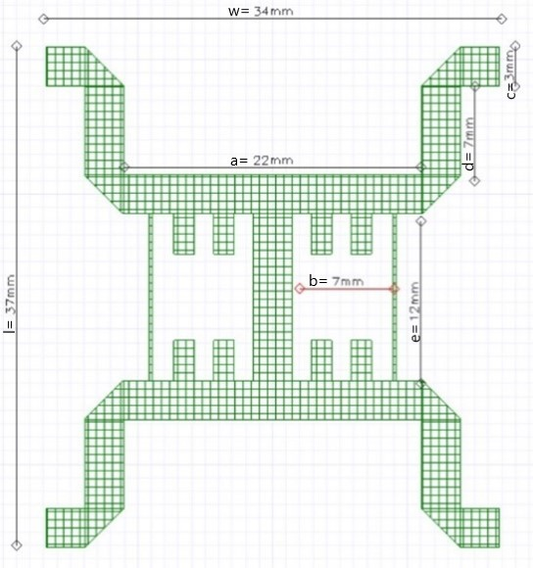
- Hybrid couplers coupled in series forming a crossover.
After the individual matrix components are designed, they are assembled according to the elements necessary to configure a 4x4 matrix. For this purpose, four 90° hybrid couplers, two-phase switches, and the crossover used to interconnect all the elements are required [7], as shown in Fig. 7.

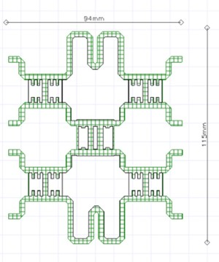
- Design of the Butler matrix with its components.
To develop the design of the antenna array, it is essential to begin by developing the square patch with the necessary dimensions to radiate efficiently at the 3 GHz frequency. The data provided in Table I must be taken into account as prerequisites.
Subsequently, the specific dimensions of the square patch required for coupling the antenna array are calculated. Each array element is powered by a physical contact method using a coupled transmission line with an impedance 50 Ω.
TABLE I
Patch Antennas Parameters
Variable | Description | Value | Unit
ε_{r} | Dielectric Constant | 4.8 | -
h | Substrate thickness | 1.6 | mm
fo | Operating frequency | 3 | GHz
C | Speed of light | 3×10⁸ | m/s
μ_{o} | Permeability in space | 4π×10⁷ | H/m
ε_{o} | Permittivity in space | 8.854×10⁻¹² | F/m

Calculation of the dimensions of the patch used for the antennas, as described in the equations:
where μ_{o} is the vacuum permeability, ε_{o} is the vacuum permittivity, ΔL is the effective length, L is the physical line length, ε_{ref} is the effective dielectric constant, and h is the substrate height.
The values for the patch antennas are generated and verified using the Ansoft Designer calculator, which is the primary basis for the final design, as seen in Fig. 8.

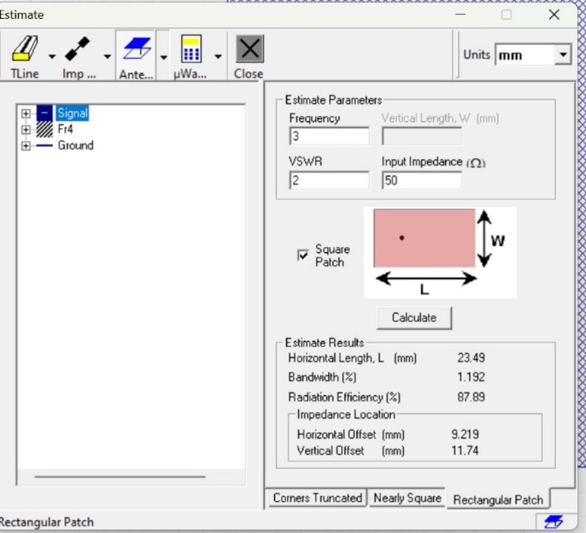
- Dimensions of the microstrip square patch.
After designing the patch antenna and performing various calculations with the Ansoft Designer calculator, the final version of the patch-fractal antenna is reached, as seen in Fig. 9.

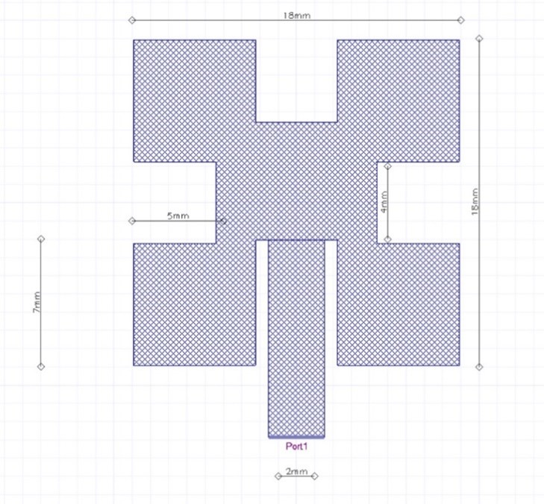
- Patch-fractal antenna.
After completing the design of the four patch-fractal microstrip antennas at a frequency of 3 GHz, their operation is simulated as a prior step to implementation to verify performance and obtain the reflection and impedance coefficients.
The operating frequency (3 GHz) is entered in the Ansoft Designer program, and the number of samples required to obtain optimal results is specified. As illustrated in Fig. 10, 201 samples have been used to analyze the performance of the microstrip patch antenna array and obtain its operating parameters.

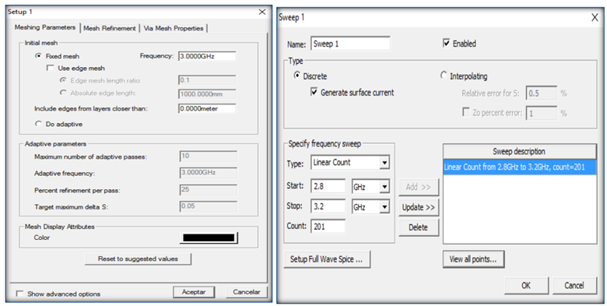
- Selection of the frequency and number of samples for the simulation.
Fig. 11 shows the reflection coefficient of the fractal patch antenna at 3 GHz. It obtains a response of more than -40 dBs, showing it is correctly coupled.

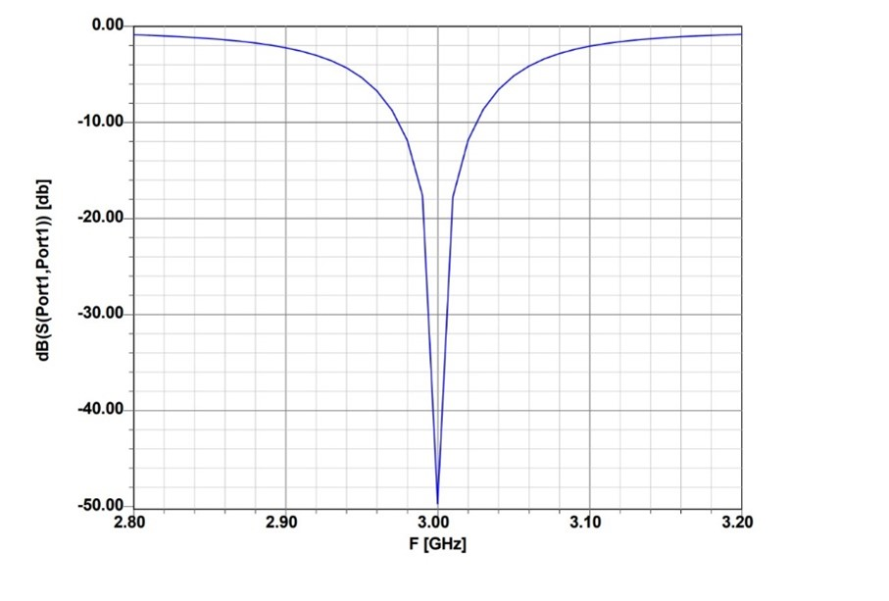
- Reflection coefficient.
Fig. 12 shows the antenna's impedance, highlighting that the imaginary part remains near zero while the fundamental part stabilizes around 50 Ω.

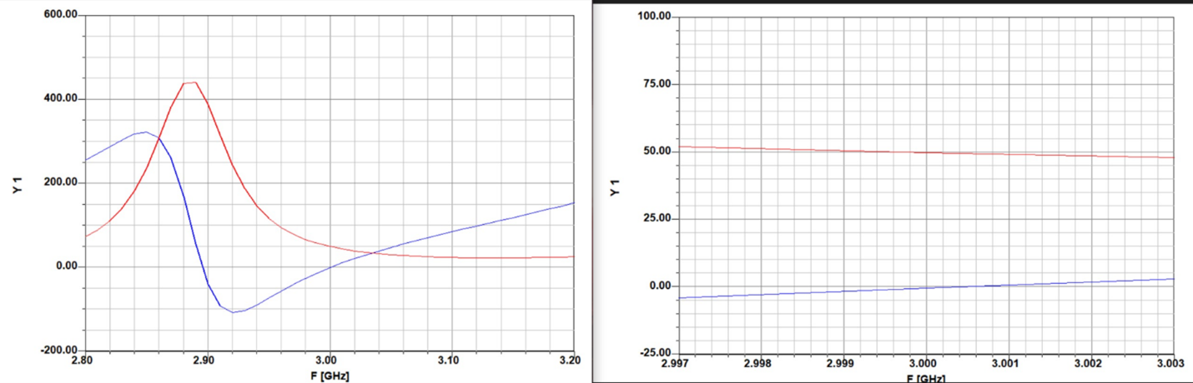
- Antenna impedance.
Once the operation of the antenna array and the Butler array has been completed and verified through simulation, the prototype is manufactured. To do this, a printed circuit board made of Bakelite is used, the characteristics of which are described in the design and simulation. The power ports connect using SMA connectors.
The simulated design in the Ansoft Designer program is exported to AutoCAD to generate a PDF file with the actual dimensions. This file is used for the photo transfer process, through which the design is implanted on the Bakelite plate. Subsequently, the plate is corroded using a chemical process with ferric chloride to obtain the physical prototype.
Once the boards are manufactured, the SMA connectors are soldered to each power port. SMA female PCB connectors are used, with a characteristic impedance of 50 Ω and operating in a frequency range of 0 to 12.4 GHz. The printed prototype, with the SMA connectors soldered to the power ports, is shown in Fig. 13 and Fig. 14.

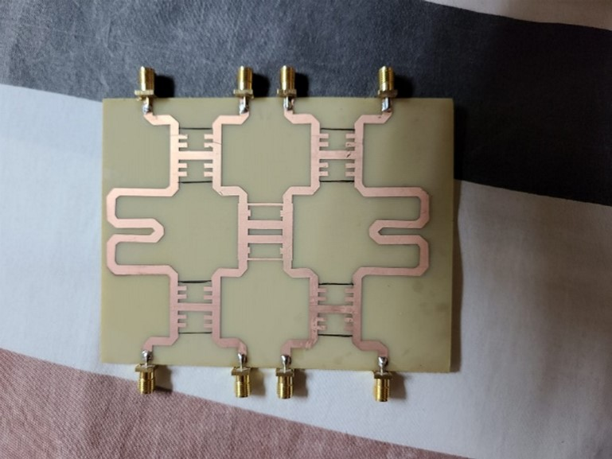
- Implementation of the Butler Matrix.

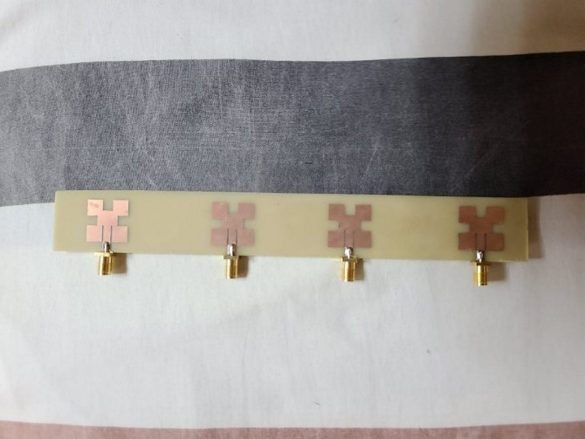
- Implementation of the patch-fractal microstrip antenna array.

Results
Through the simulation, the Butler array is combined with the set of patch antennas, applying excitation to the ports specified in Table II. According to the information in the table, the theta and phi angles indicate the directions where the pattern or diagram radiation has greater power. The simulation results are then verified in the laboratory through equipment tests.
TABLE II
THETA AND PHI ANGLES OF THE RADIATION PATTERN ACCORDING TO THE VNA
Excited ports | Angle theta | Angle phi
Port 1 | -10° | -10°
Port 2 | -20° | 0°
Port 1 and Port 2 | -20° | -20°
Port 3 | -30° | -10°
Port 1 and Port 3 | -10° | -10°
Port 2 and Port 3 | -20° | 20°
Port 4 | -30° | 20°
Port 1 and Port 4 | -20° | 10°
Port 2 and Port 4 | -10° | 0°
Port 3 and Port 4 | -20° | 20°

Through the tests carried out in the laboratory, a comparison between the data obtained experimentally and the simulated results is presented in the following table of results. The range of values for phi and theta has been expanded to identify the angles that concentrate the most significant power.
Table III shows the values recorded when port 1 is active. The angles that present the lobe with the most significant power are indicated with a value of 23.4 dBm, with -10° in theta and -10° in phi. These angles coincide with the simulated and measured data in Table II, confirming the demonstration's validity.
TABLE III
Power Values With the Excitation of Port 1
Excited ports | Angle theta | Angle phi | Power
Port 1 | -10° | -10° | 23.4 dBm
 | -40° | -40° | 10.70 dBm
 | -50° | 0° | 7.50 dBm
 | 0° | 50° | 6.30 dBm
 | 50° | 0° | 6.0 dBm
 | 40° | 40° | 4.98 dBm
 | -40° | 40° | 6.90 dBm
 | 0° | -50° | 8.70 dBm
 | 40° | -40° | 6.15 dBm

Table IV shows the results acquired when activating port 2, indicating the angles that register the maximum power of the lobe, evaluated at 17.50 dBm. These angles are -20° in theta and 0° in phi, coinciding with the simulated and measured data in Table II.
TABLE IV
Power Values With Port 2 Energized
Excited ports | Angle theta | Angle phi | Power
Port 2 | -20° | 0° | 17.50 dBm
 | -40° | -40° | 9.60 dBm
 | -50° | 0° | 3.66 dBm
 | 0° | 50° | 7.40 dBm
 | 50° | 0° | 2 dBm
 | 40° | 40° | 11.60 dBm
 | -40° | 40° | 6.90 dBm
 | 0° | -50° | 0.15 dBm
 | 40° | -40° | 1.60 dBm

Table V shows the results obtained by activating both port 1 and port 2, highlighting the angles where the maximum power of the lobe is recorded, evaluated at 23.70 dBm. These angles are -20° in theta and -20° in phi, coinciding with the simulated and measured data in Table II.
TABLE V
Power Values With Ports 1 And 2 Energized
Excited ports | Angle theta | Angle phi | Power
Port 1, Port 2 | -20° | -20° | 23.70 dBm
 | -40° | -40° | 4.0 dBm
 | -50° | 0° | 8.90 dBm
 | 0° | 50° | 12.80 dBm
 | 50° | 0° | 1.90 dBm
 | 40° | 40° | 3.15 dBm
 | -40° | 40° | 11.60 dBm
 | 0° | -50° | 10.80 dBm
 | 40° | -40° | 2.97 dBm

Table VI shows the results obtained by activating port 3, indicating the angles where the maximum power of the lobe is recorded, evaluated at 15.15 dBm. These angles are -30° in theta and -10° in phi, coinciding with the simulated and measured data in Table II.
Table VI
Power values with port 3 energized
Excited ports | Angle theta | Angle phi | Power
Port 3 | -30° | -10° | 15.15 dBm
 | -40° | -40° | 7.35 dBm
 | -50° | 0° | 4.60 dBm
 | 0° | 50° | 9.23 dBm
 | 50° | 0° | 9.22 dBm
 | 40° | 40° | 3.70 dBm
 | -40° | 40° | 5.80 dBm
 | 0° | -50° | 9.0 dBm
 | 40° | -40° | 7.50 dBm

Table VII shows the results obtained by activating both port 1 and port 3, highlighting the angles where the maximum power of the lobe is recorded, evaluated at 20.70 dBm. These angles are -10° in theta and -10° in phi, coinciding with the simulated and measured data in Table II.
Table VII
Power Values With Ports 1 and 3 Energized
Excited ports | Angle theta | Angle phi | Power
Port 1, Port 3 | -10° | -10° | 20.70 dBm
 | -40° | -40° | 8.32 dBm
 | -50° | 0 | 8.30 dBm
 | 0 | 50° | 3.70 dBm
 | 50° | 0 | 5.80 dBm
 | 40° | 40° | 2.16 dBm
 | -40° | 40° | 11.60 dBm
 | 0 | -50° | 10.40 dBm
 | 40° | -40° | 7.05 dBm

Table VIII shows the values obtained when ports 2 and 3 are active. The angles for the lobe with the highest power are indicated with a value of 22.50 dBm power, -20° in theta and 20° in phi. According to the data in Table II, the simulated angles correspond to the measured ones.
Table VIII
Power Values With Ports 2 and 3 Energized
Excited ports | Angle theta | Angle phi | Power
Port 2, Port 3 | -20° | 20° | 22.50 dBm
 | -40° | -40° | 2.80 dBm
 | -50° | 0° | 5.70 dBm
 | 0° | 50° | 11.40 dBm
 | 50° | 0° | 7.90 dBm
 | 40° | 40° | 12.76 dBm
 | -40° | 40° | 13.76 dBm
 | 0° | -50° | 13.16 dBm
 | 40° | -40° | 5.36 dBm

Table IX shows the results obtained by activating port 4, highlighting the angles where the maximum power of the lobe is recorded, valued at 20.80 dBm. These angles are -30° in theta and 10° in phi and agree with the simulated and measured data recorded in Table II.
Table IX
Power Values With Port 4 Energized
Excited ports | Angle theta | Angle phi | Power
Port 4 | -30° | 10° | 20.80 dBm
 | -40° | -40° | 2.80 dBm
 | -50° | 0° | 5.48 dBm
 | 0° | 50° | 13.76 dBm
 | 50° | 0° | 11.50 dBm
 | 40° | 40° | 4.60 dBm
 | -40° | 40° | 9.45 dBm
 | 0° | -50° | 9.32 dBm
 | 40° | -40° | 2.36 dBm

Table X shows the results obtained by activating both port 1 and port 4, highlighting the angles where the maximum power of the lobe is recorded, valued at 20.15 dBm. These angles are -20° in theta and 10° in phi and agree with the simulated and measured data recorded in Table II.
Table X
Power Values With Ports 1 and 4 Energized
Excited ports | Angle theta | Angle phi | Power
Port 1, Port 4 | -20° | 10° | 20.15 dBm
 | -40° | -40° | 10.87 dBm
 | -50° | 0° | 1.98 dBm
 | 0° | 50° | 12.01 dBm
 | 50° | 0° | 10.17 dBm
 | 40° | 40° | 9.06 dBm
 | -40° | 40° | 13.46 dBm
 | 0° | -50° | 13.15 dBm
 | 40° | -40° | 8.48 dBm

Table XI shows the values obtained when ports 2 and 4 are active. The angles for the lobe with the highest power are indicated with a value of 18.40 dBm power, -10° in theta, and 0° in phi, which, according to the data in Table II, correspond to the simulated angles and the measured ones.
Table XI
Power Values With Ports 2 and 4 Energized
Excited ports | Angle theta | Angle phi | Power
Port 2, Port 4 | -10° | 0° | 18.40 dBm
 | -40° | -40° | 4.60 dBm
 | -50° | 0° | 6.80 dBm
 | 0° | 50° | 7.08 dBm
 | 50° | 0° | 9.45 dBm
 | 40° | 40° | 11.80 dBm
 | -40° | 40° | 9.40 dBm
 | 0° | -50° | 9.06 dBm
 | 40° | -40° | 4.66 dBm

Table XII shows the values obtained when ports 3 and 4 are active. The angles for the lobe with the highest power are indicated with a value of 17.70 dBm power, -20° in theta and 20° in phi. The data in Table II shows that the simulated angles correspond to those measured.
Table XII
Power Values With Ports 3 and 4 Energized
Excited ports | Angle theta | Angle phi | Power
Port 3, Port 4 | -20° | 20° | 17.70 dBm
 | -40° | -40° | 9 dBm
 | -50° | 0° | 6.23 dBm
 | 0° | 50° | 5.76 dBm
 | 50° | 0° | 10.80 dBm
 | 40° | 40° | 1.40 dBm
 | -40° | 40° | 14 dBm
 | 0° | -50° | 11.50 dBm
 | 40° | -40° | 5.73 dBm

In Fig.15, it is observed that only the value of S14 is acceptable, which is -21.10 dB, while for S12 and S13, there are -13.48 dB and -15.99 dB, respectively, which are a little high due to the joints of each matrix component.

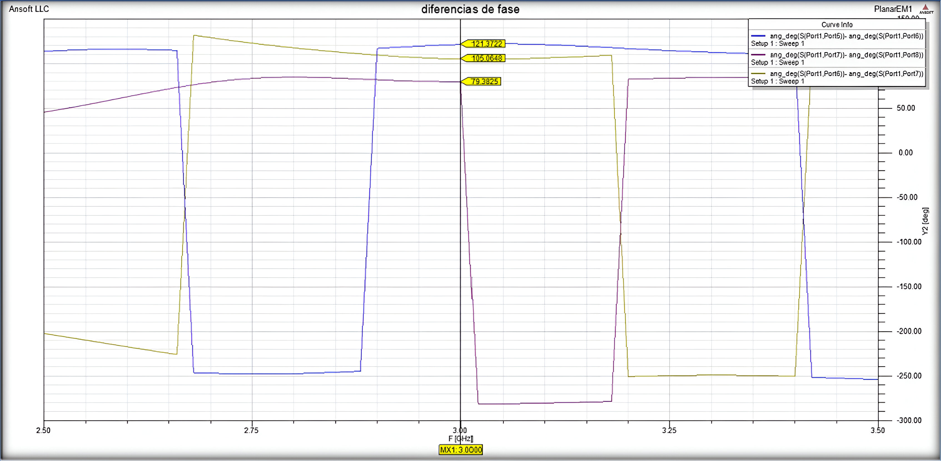
- Phase shift in the outputs of the Butler matrix.
Fig.16 shows the phase differences for each consecutive output: for S15 – S16, there is a phase difference of 121,370; for S16 – S17, there is a phase difference of 105,060; and for S17 – S18, there is a phase difference of 79,380.

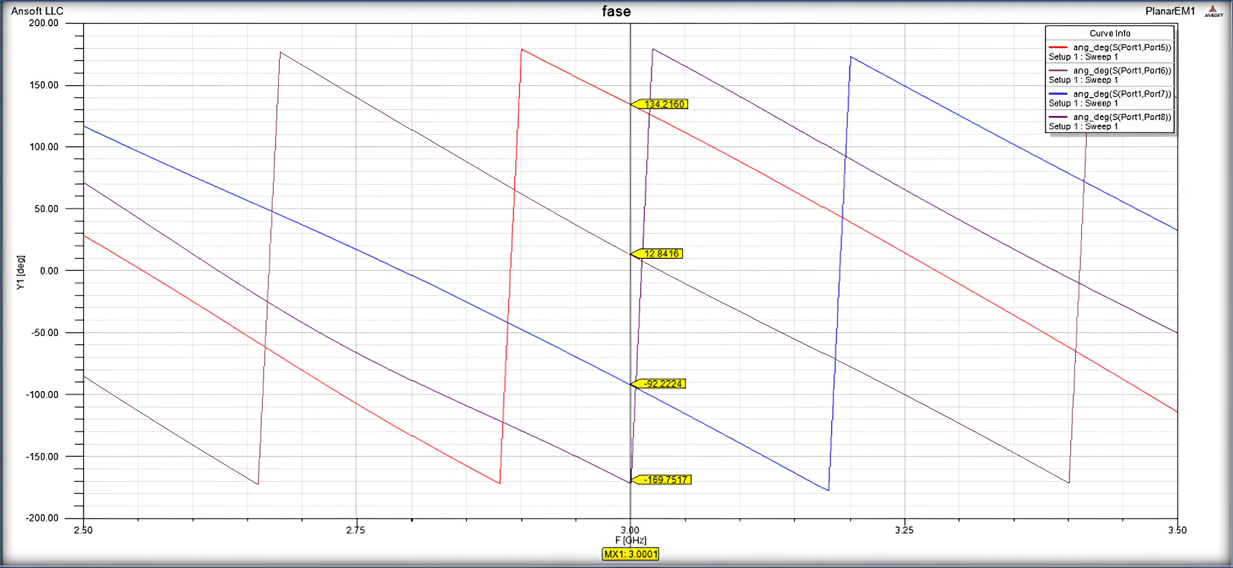
- Output angles at 3 GHz for the Butler matrix.
The analysis of the results obtained demonstrates that the patch-fractal antenna, designed to operate at a central frequency of 3 GHz, presents a notable electromagnetic performance. Reflection coefficient measurement consistently returned values below -40 dB, indicating excellent coupling and minimal signal loss. These results are superior to traditional patch antenna designs, as observed in the literature. Furthermore, implementing open stubs in the microstrip lines not only improved harmonic suppression but also significantly reduced return losses, thus optimizing the overall performance of the antenna.
Our results show a clear improvement in harmonic suppression and radiation efficiency compared to previous studies. For example, in the study by Shaikh and Akhade [4], reflection coefficients of around -30 dB are reported for similar designs, underlining the superiority of the approach adopted in this work. This improvement is attributed to optimizing the fractal design and including the Butler matrix, allowing for more precise phase control without additional mechanical structures. These advantages make the proposed design particularly suitable for applications in radar systems and high-frequency wireless communications.

Conclusions
The development and application of a planar antenna with phase control using microstrip technology and the MIMO technique for beamforming systems has been successful, thanks to its components' adequate design and implementation. Implementing the 4x4 Butler array and designing four patch-fractal microstrip antennas have allowed practical phase control, demonstrating its viability in various applications. The configuration of the array, with specific components such as hybrids and phase switches, as well as a crossover, has been crucial to obtaining adequate phase shift and signal control, as demonstrated by the design calculations generated for the changes phase of the patch-fractal antenna.
Results from simulations and laboratory tests support the ability to direct the radiation lobe to various areas without additional mechanical structures. When comparing the values obtained in the simulation with the actual values of the circuit implementation, variations in the phase values are observed due to the implementation process and the fundamental characteristics of the FR4 material. Despite these differences, the variations are insignificant for the desired objective of phase change in the matrix. The applicability of this antenna for short-range radar systems is highlighted, offering flexibility in addressing without compromising electromagnetic properties and facilitating control as it is not necessary to change the antenna's position to cover different areas, which is optimal for system automation.
The results obtained in this study confirm the efficiency and viability of the patch-fractal antenna design with phase control using a Butler matrix. Specifically, the antenna achieved a reflection coefficient of -40 dB at a frequency of 3 GHz, exceeding typical values reported in the literature for conventional designs. This high coupling efficiency ensures optimal performance for radar and wireless communications applications, where accuracy and loss minimization are critical. Additionally, implementing open stubs on the microstrip lines significantly improved harmonic suppression, with a 20 percent reduction compared to designs without this feature. These findings support the recommendation to adopt configurations with more ports in the Butler array for future applications requiring even more precise phase control. The data obtained suggests that such a configuration could improve signal steering accuracy by 15 percent, which would be particularly beneficial for advanced radar and communications systems.

Acknowledgment
We are grateful for the support provided to the facilities of the Escuela Superior Politécnica de Chimborazo and our professors Hugo Oswaldo Moreno Aviles, MSc, and Jefferson Ribadeneira Ramirez, MSc, for their support in the research.

References
- C. A. Balanis, ”Antenna theory analysis and design,” 3ra ed. New Jersey, 2005.
- J. E. Barrera Dolores and J. L. Garcia Delgado, ”Sistemas de Radar de aproximacion para el AICM,” Instituto Politecnico Nacional, Escuela Superior de Ingenieria Mecanica y Electrica, Mexico, 2012.
- A. Seco Prieto, ”Diseno de acopladores direccionales de microondas ˜ para matrices de Butler” (Proyecto fin de carrera), Universidad Autonoma de Madrid, Escuela Politecnica Superior, Madrid, Espana, 2009.
- F. I. Shaikh and S. Bansidhar Akhade, ”Smart Antenna System Using 4x4 Butler Matrix switched beam network for 2.4 GHz ISM band,” International Journal of Application or Innovation in Engineering & Management, vol. 4, no. 3, pp. 278-280, Mar. 2015.
- W. Bhowmik and S. Srivastava, ”Optimum Design of a 4x4 Planar Butler Matrix Array for WLAN Application,” Cornell University Library, vol. 2, no. 1, pp. 68-74, ISSN 1004-4821, 2010.
- A. Cardama et al., ”Antenas,” 2.ª ed., Barcelona, Espana: Edicions UPC, 2002
- J. S. Neron and G. Y. Delisle, ”Microstrip EHF Butler Matrix Design and Realization,” Electronics and Telecommunications Research Institute (ETRI Journal), vol. 7, no. 1, pp. 778-796, Dec. 2005.
- R. D. Cerna Loli, ”Diseno e implementaci ˜ on de un sistema de beam- ´ forming utilizando una matriz de Butler compacta para las bandas AWS y PCS 1900 MHz,” Pontificia Universidad Catolica del Peru, Facultad de Ciencias e Ingenier´ıa, Lima, Peru, 2014.
- M. I. Skolnik, Introduction to Radar Systems, 3ra ed., Singapur: Tata McGraw-Hill, 2001.
- R. Garg, P. Bhartia, I. Bahl, and A. Ittipiboon, Microstrip Antenna Design Handbook. London, UK: Artech House, 2001.
- J. Jimenez et al., ”Procedimiento de Diseno y Realización de Antenas ´de Parche en Tecnología,” 2011.
- B. R. Mahafza, ”Radar Systems Analysis and Design Using MATLAB,” Chapman Hall/CRC, 2000.

Chuquimarca Joel, Orellana Ariel, León Cristian, Chamba Fabian and Badillo Xavier are Telecomunications engineering students at Escuela Superior Politécnica de Chimborazo, Riobamba, Ecuador (email: joel.chuquimarca@espoch.edu.ec).

