Comparison of interior propagation models of the Wi-Fi network at the 5785 MHz band through RSSI measurements

Comparación de modelos de propagación interior de la red Wi-Fi en la banda de 5785 MHz mediante medidas RSSI
Dayana Pilco, María Díaz
Abstract—This study presents a comparative analysis of the Cost231-Multi-Wall Model, the Motley-Keenan Model, the Modified Free Space Model, and the Log-Normal Shadowing Path Loss Model, applied to a 5G Wi-Fi network in an indoor analysis. The research seeks to recommend the most appropriate small-scale propagation model based on empirical measurements of signal strength. Initially, the router is located within the analysis area. Then, a detailed sketch is made in SketchUp, locating 133 points around the primary router, covering the entire indoor area of the analysis, ensuring an accurate assessment of the cellular network coverage. Subsequently, with the data collected over three campaigns, propagation losses were calculated to determine the theoretical power of each model and compare the measured power values with the theoretical power values to obtain a specific model. The four propagation models analyzed in the evaluator are based on data obtained in the range [-20 to-91] dBm. It was concluded that the Keenan-Motley propagation model offered a better fit to the measurements, presenting a value of 12.59 dB. In contrast, the Cost 231 model showed a value of 17.18 dB, the Modified Free Space model showed a value of 26.47 dB, and the Log-Normal Shadowing Path Loss model showed a value of 27.57 dB, indicating a greater discrepancy concerning the measured data. This model demonstrated greater accuracy in predicting the reception power compared to the other analysis models, adapting better to the specific characteristics of the environment. These results highlight the importance of strategically locating the router; therefore, it is recommended to locate it in a central location.

Index Terms—Propagation Models, indoor 5G Wi-Fi, signal strength measurement, model comparison, router placement.

Resumen—Este estudio presenta un análisis comparativo del Modelo Cost231-Multi-Wall, el Modelo Motley-Keenan, el Modelo de Espacio Libre Modificado y el Modelo de Pérdida de Trayectoria por Sombreado Log-Normal, aplicado a una red Wi-Fi 5G en un análisis en interiores. La investigación busca recomendar el modelo de propagación a pequeña escala más apropiado con base en mediciones empíricas de la intensidad de la señal. Inicialmente, el enrutador se ubica dentro del área de análisis. Luego, se crea un boceto detallado en SketchUp, ubicando 133 puntos alrededor del enrutador principal, cubriendo toda el área interior del análisis, lo que garantiza una evaluación precisa de la cobertura de la red celular. Posteriormente, con los datos recopilados durante tres campañas, se calcularon las pérdidas de propagación para determinar la potencia teórica de cada modelo y comparar los valores de potencia medidos con los valores de potencia teóricos para obtener un modelo específico. Los cuatro modelos de propagación analizados en el evaluador se basan en datos obtenidos en el rango de [-20 a -91] dBm. Se concluyó que el modelo de propagación Keenan-Motley ofreció un mejor ajuste a las mediciones, presentando un valor de 12,59 dB. En contraste, el modelo Cost 231 mostró un valor de 17,18 dB, el modelo de Espacio Libre Modificado mostró un valor de 26,47 dB y el modelo Log-Normal Shadowing Path Loss mostró un valor de 27,57 dB, lo que indica una mayor discrepancia con respecto a los datos medidos. Este modelo demostró mayor precisión en la predicción de la potencia de recepción en comparación con los otros modelos de análisis, adaptándose mejor a las características específicas del entorno. Estos resultados resaltan la importancia de ubicar estratégicamente el enrutador; por lo tanto, se recomienda ubicarlo en una ubicación central.

Palabras Claves—Modelos de propagación, Wi-Fi 5G en interiores, medición de la intensidad de la señal, comparación de modelos, ubicación del enrutador.

Introduction
T
he technological advances experienced daily have radically changed people’s lives, especially in the field of mobile telecommunications [1]. These advances are reflected in the study of interference, particularly when implementing new network infrastructures. For the analysis of signal power in different environments (urban, suburban, rural, and indoor), the use of propagation models is crucial; these adopt the laws of physics, where they determine how radio waves are dispersed, refracted, and reflected [2].
Wi-Fi networks, which operate on the 2.4 GHz and 5 GHz frequencies, also play a fundamental role in everyday connectivity. The 2.4 GHz network, although more susceptible to interference due to device congestion on this frequency, offers greater range, making it ideal for covering vast areas. However, its performance is often compromised by the presence of other electronic devices, such as microwaves or cordless phones, using the same band. On the other hand, the 5 GHz network provides faster connection speeds due to fewer devices on this frequency. Although its range is shorter compared to 2.4 GHz, the 5 GHz network is better suited for environments with high bandwidth demands, such as streaming high-definition video or online gaming [3].
Small-scale propagation models in mobile telephony are designed to study the variation in the received power of an emitted signal. The Motley-Keenan model analyzes signal loss by considering several factors, such as the distance between the transmitter and receiver and physical obstacles (walls, floors, doors, or ceilings). This model is beneficial because it allows the loss estimate to be customized for each specific environment, using empirical values for each type of obstacle, making it ideal for designing Wi-Fi, Bluetooth, or indoor communication systems [4]. The Cost 231 model is an extension of the Okumura Hata model, which was initially designed for urban environments but is also often used indoors. This model considers path loss as a function of frequency, distance, and certain correction factors, including the type of environment (such as office buildings or factories) [5].
A comparative analysis of the two models shows that the Motley-Keenan model is specifically designed for indoor environments because it offers a better representation of the actual attenuation within specific locations, especially in locations with multiple subdivisions. Therefore, this paper presents a comparative analysis of the propagation models to select the most appropriate model that achieves good quality of service while ensuring efficient connectivity in a variety of contexts, facilitating the development of emerging technologies such as the Internet of Things (IoT) deployed in 4G and 5G networks [6].

Indoor Propagation Models

Keenan-Motley
The modified-free-space model analyzes the distances between the building walls and the penetration losses of the walls. The model, according to Motley and Keenan, computes the path loss based on the direct ray between transmitter and receiver. In contrast to the modified free space model, this model considers the exact locations of the walls, floors, and ceilings. Additional factors for absorption of the direct ray path by walls are considered [7], [8].
Designed exclusively for propagation in indoor environments, this empirical model considers both free space loss and the additional loss that occurs when the direct signal between the transmitter and receiver passes through different walls and floors. [9] Its application requires a large volume of data, and the signal attenuation is determined through:
where L₀ is the propagation losses at one (1) meter from the transmitting antenna, in dB, L_{f,i} is the propagation losses of the signal through floors, in dB, N_{f,I} is the number of floors with the same characteristics, L_{w,j} is the propagation losses of the signal through walls, in dB, N_{w,j} is the number of walls with the same characteristics, i is the number of types of floors crossed by the signal, and j is the number of types of walls crossed by the signal.
As shown in Fig. 1, the parameter kw describes the number of walls intersected by the direct path between transmitter and receiver. A uniform transmission (penetration) loss L_{w} for all walls is used for the computation; that is, the material properties of the individual walls are not considered. This uniform transmission loss can be specified by using the Settings button [10].

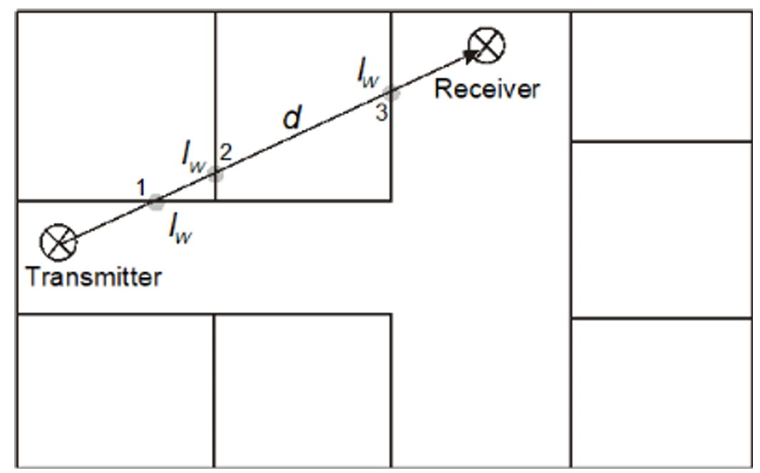
- Principle of the Motley-Keenan model.
The Keenan-Motley model is used to analyze signal loss, considering factors such as distance and physical obstacles. Total attenuation is calculated by adding the free-space loss and the additional losses caused by walls and floors. The equation used is:
where L is the total loss of signal in decibels (dB), d is the distance between the transmitter and the receiver, N_{f} is the number of floors crossed by the signal, L_{f} is the propagation losses through floors, in dB, L_{w1} are the losses in lightweight walls such as wood or doors, and L_{w2} are the losses in thick walls such as brick or concrete
In Table I, the typical values of the mentioned losses are shown:
Table I
Loss factors according to wall type
Type of loss | Attenuation range (dB)
L_{f} | 13-27
L_{w1} | 2-4
L_{w2} | 8-12

Cost 231-multi-wall
The COST 231 Multi-wall (MWM) model, an extension of the COST 231 Keenan and Motley propagation model, introduces a linear loss component that is proportional to the number of walls traversed by the signal. In addition, it includes a more complex term related to the number of floors crossed. This additional term takes into account that signal loss increases at a slower rate after the first floor traversed, reflecting a decrease in incremental attenuation as the signal traverses more floors [9], [14].
Overall, the total attenuation in the COST 231 Multi-wall model is calculated by adding the free space loss, the loss due to the number of walls, and the loss due to the number of floors. [15] This approach allows for a more accurate representation of signal propagation in complex indoor environments, where multiple obstacles can significantly impact signal quality. According to Saunders (2007), this model is beneficial for designing and optimizing wireless networks in buildings, providing an effective tool to predict coverage and improve network planning [16], [17].
where γ is the path loss exponent and b is an attenuation factor associated with the floors that the signal must pass through.
In any case, the propagation model in free space is represented by the previous equation.
where f is the operating frequency in GHz.
This model accounts for losses due to walls and floors, as shown in Tables II and III. Therefore, the following parameters are used for each scenario:
Table II
Material losses for the cost 231-multi-wall model
Description | Material | Factor (dB)
L_{f} | Floors (typical structure)  Tiles or concrete covering, thickness ¡ 30 cm | 18.3
L_{wi} | Thin internal walls, Plaster or wall with openings (windows and/or doors), width ¡ 10 cm | 3.4
L_{wi} | Thick internal walls, Concrete or Brick width ¿ 10 cm | 6.9
Table III
Material losses for the cost 231-multi-wall model
Wall material | Thickness (cm) | Attenuation (dB)
Wood | 0.4 | Lw11=0.9
Plasterboard | 13.5 | Lw21=3.0
Glass | 1.5 | Lw41=2.5
Double-glazed window (12 mm air gap) | 2.0 | Lw51=12
Reinforced concrete block | 30.2 | Lw61 = 10

Methodology
To better understand the focus of this research, Fig. 2 presents a representative diagram of the router’s (Access Point) location and how the signal propagates in different directions within an indoor environment. In this specific case, the analysis was carried out inside a home, where it was identified that the signal must cross various physical obstacles such as walls, windows, desks, floors, and ceilings, among others. These conditions directly influence the quality and range of the wireless signal. For this reason, it is essential to correctly locate the access point to ensure better signal diffusion between the transmitter (the Access Point itself) and the receiver, which in this context corresponds to the end user, who accesses the service through a technological device with an Internet connection.

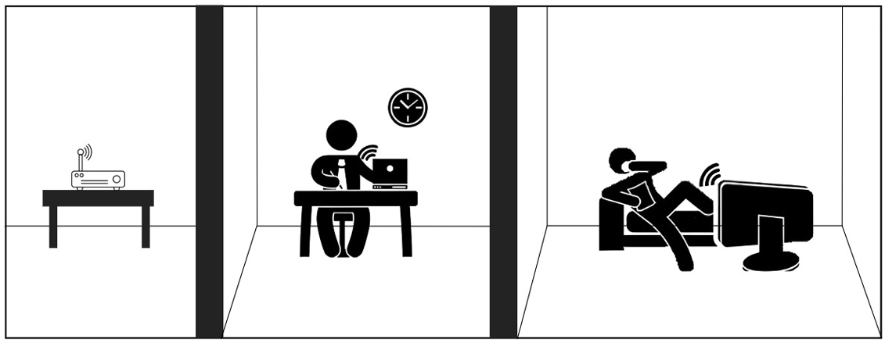
- Diagram of an access point transmission in a house.
For indoor propagation measurements, a Huawei EchoLife HS8546V5 Gigabit smart home solution intelligent gateway device, shown in Fig. 3, was used. It offers a POTS voice interface, 4 GE/FE adaptive Ethernet ports, and dual-band WiFi (2.4 GHz and 5 GHz). It offers application flexibility, plug-and-play support, remote diagnosis, green power saving, and other functions [18].

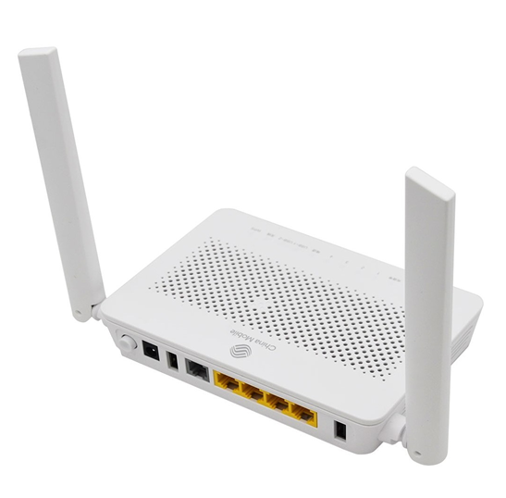
- Router Huawei EchoLife HS8546V5.
The HS8546V5 features a transmission power of up to 20 dBm for 802.11n WLAN networks in the 2.4 GHz band, and up to 26 dBm for 802.11ac networks in the 5 GHz band. It operates over a GPON interface and features compact dimensions of 173 mm long, 120 mm wide, and 30 mm high. It is equipped with two fixed external antennas, each with a 5 dBi gain, enabling more exhaustive and optimized signal coverage. These specifications make it an ideal device for efficient data transmission and reliable coverage, especially in indoor environments during measurement processes [19].
Measurements were taken in the city of Riobamba, Ecuador, at an altitude of 2,754 meters above sea level, with an average temperature of approximately 13°C. The house is a single-story country house, spanning approximately 150 square meters. The walls are made of kiln-fired clay brick, rectangular with dimensions of 24 cm long, 12 cm wide, and 7 cm high. Inside, each wall is plastered (a thin layer of mortar to smooth, protect, and prepare the surface for the final finish), plastered, and painted with water-based paint. Outside, the exposed brick finish is preserved. The roof is composed of fiber cement sheets with additives, silica, and cellulose fiber, supported by a metal frame. Beneath this is a “ceiling” structure, which acts as a false ceiling to conceal the roof structure.
A network of measuring points was established within the home, with a total of 133 points distributed as follows: 25 points in the main room (Room II), where the access point is located; 15 points in Room I; 29 points in Room III; 38 points in the kitchen (including the kitchen itself); 6 points in the bathroom; 12 points in the hallway; and 10 points in the basement. These measuring points were distributed proportionally to each square meter of the different interior spaces of the home, and a 1.25 m over the floor, as shown in Fig. 4.
To capture the signal data, the ”WIFI Heatmap” application was used, which allowed analyzing the bandwidth provided by the WiFi network, as detailed in Fig. 5. In addition, the SketchUp and Epic Games Launcher tools were used in Unreal Engine, specifically in version 3.5.2, to create both the 2D and 3D scenery and model the environment in detail.
The 5 GHz network, being less congested, experiences less interference, resulting in a faster connection. Additionally, it offers a greater number of available channels, providing additional space for device distribution in Fig. 6. Due to these advantages, it was decided to use the 5 GHz network for the measurements, thus ensuring greater quality and precision in the data obtained.
Several parameters are needed to calculate the propagation losses for each model. To determine the receiving power, it is necessary to implement equation (5), where P_{r} is the receiving power, P_{t} is the transmitting power, G_{t} is the gain of the transmitting antenna, G_{r} is the gain of the antenna of the mobile system, which is usually 1.5 dB, and L are the losses obtained according to each model.

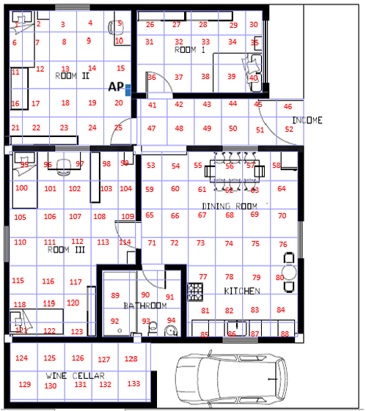
- WiFi network measurement points: implementation in SketchUp.

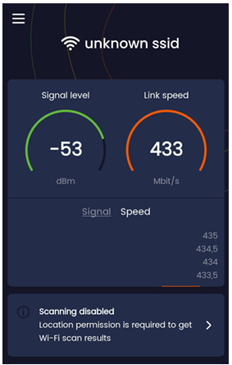
- Wifi Heatmap application to determine the bandwidth of the WiFi network.

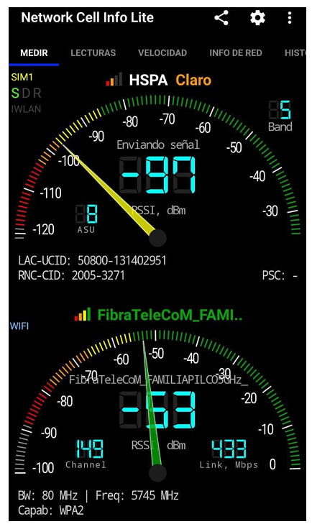
- Network Cell Info Lite application for operating band determination.
Fig. 7 presents the results of signal strength measurements carried out inside a house with brick walls and tile floors, with the router located on the second floor. Measurements show a progressive decrease in received signal power as the distance from the router increases. This attenuation can be attributed to several factors, such as signal reflection from tile flooring, diffraction caused by obstacles such as furniture and walls, and inherent free space losses. These variations highlight the complexity of signal propagation in a home environment and the importance of strategic router placement to maximize coverage.
Furthermore, the structure of the building, especially the thickness of the brick walls, plays a crucial role in signal degradation. RF signals are significantly attenuated when passing through dense materials, which explains notable decreases in signal strength in different rooms and floors. These results underscore the need for careful planning of access point placement and network configuration to ensure optimal wireless connectivity in complex home environments.

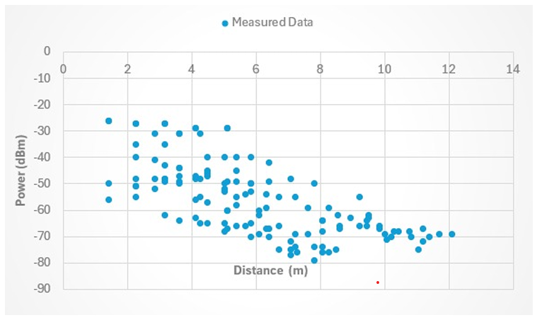
- Measured power.

Transmission Power Analysis
Calculating the actual transmit power of the Huawei HS8546V5 access point is crucial, as it may differ from the power specified in the device’s data sheet. In practice, the adequate power tends to decrease when multiple users are connected at the same time. This occurs because the router must distribute its capacity among all connected devices, which can reduce the transmission power available for each one. Therefore, estimating the real power allows a better understanding of the router’s performance in real conditions and facilitates network optimization to ensure more efficient and balanced connectivity for all users.
The following equation is used to calculate the actual adequate isotropic radiated power (EIRP) emitted by the router. The EIRP considers not only the transmit power of the router, but also the gain of the antennas and the losses in the cables and connectors. This calculation is essential to understand the actual range and coverage of the router, allowing more precise network planning and the implementation of measures to improve signal quality in different areas of the home environment.
The received power measured directly at 2 meters from the access point was -29 dBm, as shown in Fig. 8. This measurement resulted in an adequate isotropic radiated power (EIRP) of 26.94 dBm. The measurement was performed in an anechoic chamber, ensuring a controlled environment free from external interference. The obtained value of 26.94 dBm is consistent with the value specified in the access point’s data sheet, which indicates an EIRP of 26 dBm.

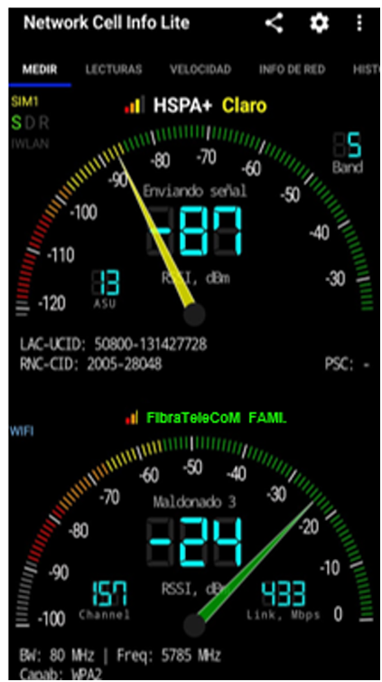
- Power measured at 2 meters from the router.

Results
This section compares the propagation losses obtained using different applied models, allowing their accuracy and applicability to be evaluated in real conditions. Cost231Multi-Wall, the Motley-Keenan, Modified Free Space, and LogNormal Shadowing Path Loss, taking into account factors such as diffraction and reflection from obstacles. Comparing these models with real measurements is essential to optimizing the design and planning of communication networks, as well as to determining the optimal placement of routers. This ensures greater efficiency and adequate coverage in various environments.

Keenan-Motley model
Theoretical data for the Motley-Keenan model were calculated using (2) as it is more appropriate for the measurement environment. This is because not all the data necessary to apply the general equation of the Motley-Keenan model was available. Table IV presents the parameters used in this model, based on the information provided in Table II.
Table IV
Motley-Keeman Parameters
L_{f} | 14
L_{w1} | 3
L_{w2} | 9

Fig. 9 shows the measured data points (blue dots) and the theoretical predictions of the Keenan-Motley model (green dots). It is noted that there is a concentration of blue dots near the model’s prediction curve, suggesting a good approximation. The Keenan-Motley model had an error of 12.59 dB, indicating that it best fits the measurements taken in the brickwalled house. This figure demonstrates the model’s accuracy in estimating receiving power in an indoor environment with multiple obstacles and subdivisions.

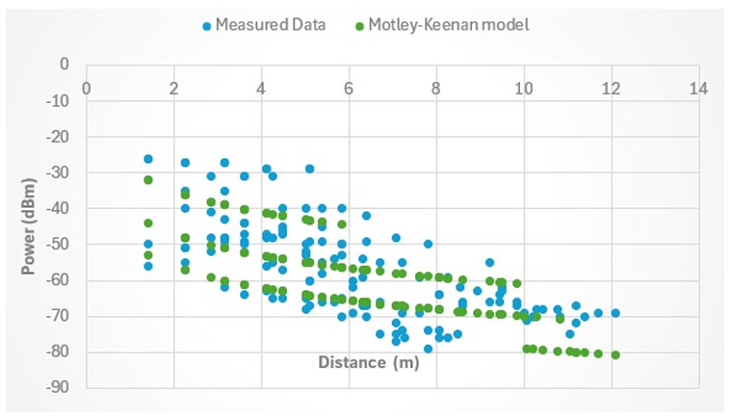
- Keenan-Motley model.

Log-Normal Shadowing Path Loss model
In Fig. 10, the measured data (light blue dots) are compared with the prediction curve of the Log-Normal Shadowing Path Loss model (red dots). It can be seen that most of the measured points do not align with the model curve. The high error value (27.57 dB) confirms that this model is not suitable for the measurement environment. It can be inferred that this model, although it incorporates a log-normal distribution term for fading, does not effectively capture the specific characteristics of the analyzed residential environment.

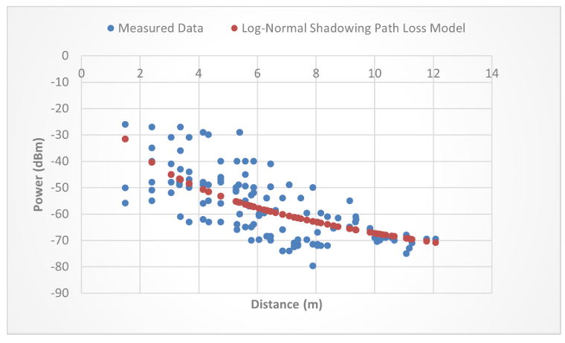
- Log-normal shadowing path loss model.

Cost 231-Multi-Wall model
Theoretical data for the Cost-Multi-Wall model were calculated using Equation 3. Data were taken from Tables II and III and adjusted according to the measurement environment and the number of walls or floors present in each scenario. Furthermore, the values of γ and b were set to 2 and 0.46, respectively.
Fig. 11 compares the measured data (light blue dots) with the prediction curve of the Cost 231-Multi-Wall model (blue dots). At first glance, it is noticeable that the measured and predicted points are clustered together, but in different locations on the graph. Although this model accounts for loss through walls and floors, its error of 17.18 dB is significantly higher than that of the Keenan-Motley model. The figure indicates that the model is not well-suited to this type of building, with brick walls and fiber cement roofs, which limits its ability to predict reception power in this particular scenario.

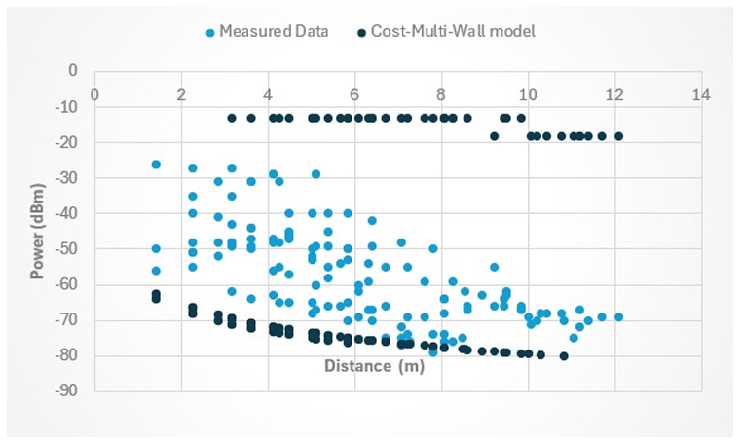
- Cost 231-Multi-Wall model.

Modified Free Space model
The model uses parameters such as the horizontal distance between the transmitter and receiver. This distance is determined using the right triangle formula to calculate the hypotenuse, which represents the horizontal distance. The equations were applied because all the necessary data were available for the measurement environment. Since the measurements were taken in a home, a setting similar to an office building, parameters appropriate for that type of environment were used.
Finally, Figure 12 shows the measured data (light blue dots) and the predictions of the Modified Free Space model (purple dots). The prediction curve is considerably far from the measured points, suggesting that this model, by assuming ideal conditions with minimal obstructions, is not appropriate for an indoor environment with walls, furniture, and other barriers. The error of 26.47 dB confirms this, placing it as one of the least accurate models for this study.

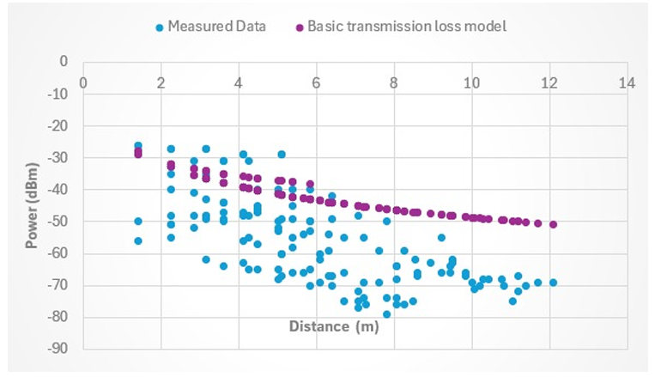
- Modified free-space model.

Mean square error
Table V presents the results of the mean square errors (MSE) obtained for different propagation models evaluated in the study environment. It is observed that the Keenan-Motley model presents the lowest root mean square error, indicating that it is the model that best fits the measured data, showing greater accuracy in estimating the reception power. This behavior suggests that, in the specific context of this study, the Keenan-Motley model is the most suitable for predicting signal distribution in indoor environments with multiple walls and obstacles. In contrast, other models show higher MSE (mean square error), indicating lower accuracy in their predictions.
Table V
Comparison of propagation models in the evaluated environment
Propagation model | MSE (dB²) | RMSE (dB)
Motley-Keenan | 158.56 | 12.59
Log-Normal Shadowing Path Loss | 760.15 | 27.57
Cost-Multi-Wall | 295.25 | 17.18
Modified Free Space | 700.78 | 26.47

Mapping of Received Powers.
To evaluate the reception strength of a 5G Wi-Fi network, measurements were taken inside a home located in the rural area of Riobamba. One hundred thirty-three sampling points were recorded, spaced one square meter apart, providing a detailed view of the signal distribution within the property.
Initially, SketchUp was used to create 2D and 3D models of the study area, ensuring an accurate representation of the physical environment. The collected data was then integrated into Unreal Engine (version 3.5.2 by Epic Games), where the reception strength was modeled and visualized in a three-dimensional and dynamic manner, facilitating a more realistic and understandable analysis.
Fig. 13 shows the visualization generated in Unreal Engine, using a color palette ranging from green (good reception) to white and red (poor reception). This clear representation makes it easy to identify areas with good coverage, as well as those that might require adjustments to the router’s location or network settings to improve performance.

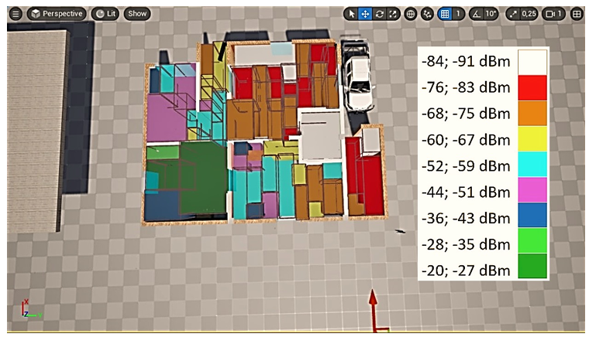
- Mapping of Received Powers.

Conclusions
The received power measured directly at 2 meters from the access point in the anechoic chamber, with a value of -29 dBm, yielded an adequate isotropically radiated power (EIRP) of 26.94 dBm. This value matches the value provided in the access point’s data sheet, which specifies an EIRP of 26 dBm, confirming that the access point operates according to the manufacturer’s specifications and that the measurement in the anechoic chamber was accurate, as it was performed in an interference-free environment.
For the propagation analysis, two propagation models were applied to data obtained from a total of 133 measurement points distributed throughout key spaces in the home, including the kitchen, hallway, bedrooms, and basement, to assess coverage under various environmental conditions. The data obtained were compared with the results of the Keenan-Motley and Cost 231 propagation models. The Keenan-Motley model showed an error of only 12.59 dB, providing a better fit to the home environment. In contrast, the Cost 231 model had an error of 17.18 dB, the Log-Normal Shadowing Path Loss model had an error of 27.57 dB, and the Modified Free Space model had an error of 26.47 dB, indicating a greater discrepancy with current measurements. This model is less suitable for these types of environments, characterized by brick, plaster, and metal-framed fiber cement roofs. These structural characteristics affect signal propagation, making the Keenan-Motley model more appropriate for this type of building.
Using the measurement data, an electromagnetic map was generated that visualizes signal distribution in the evaluated environment. This mapping facilitates understanding how the signal propagates in different spaces, providing an educational tool to explain signal processing and power distribution based on the structural characteristics of the environment. Therefore, the mapping serves as a visual resource to practically illustrate how environmental variables affect electromagnetic coverage and propagation.
Beyond root mean square errors (RMSE), each model’s implementation presents its limitations. The Keenan-Motley model, while the most accurate in this study, requires a significant amount of empirical data and a detailed description of obstacles for calibration. Its adaptability to different materials is high, as it allows for customized losses by wall and floor. On the other hand, the Cost 231-Multi-Wall model, although it also considers obstacles, proved less adaptable to the specific environment of this study, possibly due to the construction characteristics of the home.
The Log-Normal Shadowing Path Loss and Modified Free Space models are more straightforward to implement. Still, their accuracy decreases considerably in complex environments, limiting their usefulness for detailed indoor network planning.
As future work, we plan to implement machine learning and deep learning models to improve accuracy and adapt to more complex scenarios. Incorporating these techniques would allow for more robust analysis and more accurate results.

References|
- J. Pérez, “Impacto de las nuevas tecnologías móviles en la sociedad,” Revista UNESUM Ciencias, vol. 7, no. 1, pp. 4560, 2025. [Online]. Available: https://revistas.unesum.edu.ec/index.php/ unesumciencias/article/view/474/591
- Naciones Unidas, “Influencia de las tecnologías digitales,” https://www.un.org/es/un75/impact-digital-technologies, 2020, accedido: 16 de abril de 2025.
- S. M. Cordero, “Análisis de la calidad de señal en una red wi-fi con la herramienta netstumbler,” Umbral Científico, vol. 7, pp. 61–71, 2005. [Online]. Available: https://www.redalyc.org/pdf/304/30400708.pdf
- J. L. Camargo Olivares. (2009) Modelos de propagación en interiores. [Online]. Available: https://biblus.us.es/bibing/proyectos/abreproy/11761/fichero/Volumen2%252F11-Cap%C3%ADtulo6+-+Modelos+de+propagaci%C3%B3n+en+interiores.pdf
- Xirio Online, “COST 231,” 2025, accedido: 16 de abril de 2025. [Online]. Available: https://www.xirio-online.com/web/help/es/cost 231.htm
- S. P. R. Torres, and A. J. G. Meza, “Fundamentos de las comunicaciones móviles,” Universidad Tecnológica de Bolívar, Cartagena, Colombia, 2008, disponible en: https://biblioteca.utb.edu.co/notas/tesis/ 0043125.pdf.
- S. Sadowski and P. Spachos, “RSSI-based indoor localization with the internet of things,” IEEE Access, vol. 6, pp. 30149–30161, 2018.
- A. M. Al-Samman, T. Abd. Rahman, T. Al-Hadhrami, A. Daho, M. N. Hindia, M. H. Azmi, K. Dimyati, and M. Alazab, “Comparative study of indoor propagation model below and above 6 GHz for 5 G wireless networks,” Electronics, vol. 8, no. 1, p. 44, 2019. [Online]. Available: https://doi.org/10.3390/electronics8010044
- C. Maldonado, N. Pérez García, J. Uzcátegui, and E. Malaver, “Nuevo modelo de propagación para redes wlan operando en 2.4 ghz, en ambientes interiores,” Télématique, vol. 9, pp. 1–22, 01 2010.
- O. A. Guzm´an Obreg´on, S. Fern´andez, Y. Arbella, and W. Calzadilla, “Indoor propagation models in mobile communications,” 11 2010.
- G. Keenan and F. Motley, “A new propagation model for urban environments,” IEEE Transactions on Communications, vol. 45, no. 3, pp. 201–213, 1997.
- G. Molina and J. Keenan, Propagation Models and Predictions for Wireless Communications, 1st ed. New York: Springer, 2000.
- I. Altair Engineering, Motley-Keenan Model (MK), 2022. [Online]. Available: https://2022.help.altair.com/2022.1/winprop/topics/winprop/ user guide/propagation methods/propagation models indoor mk.htm
- E. C. in the Field of Scientific and T. R. (COST), “Urban transmission loss models for mobile radio in the 900 and 1800 MHz bands,” COST 231 Final Report, 1999, available online at the COST 231 project website.
- M. Hata, Empirical Formula for Propagation Loss in Land Mobile Radio Services. IEEE, 1980, vol. 29, no. 3.
- R. Ogilvie. (2024) Modelo cost. [Online]. Available: https:// www.studocu.com/latam/document/universidad-tecnologica-de-panama/ comunicaciones-i/modelo-cost/85013323
- E. C. in the Field of Scientific and T. R. (COST), Final Report of COST 231: Digital Mobile Communications. Brussels: COST, 1999.
- Huawei, “Echolife hg8546m5,” 2024, accessed: 2024-07-24. [Online]. Available: https://support.huawei.com/enterprise/es/spanish-documents/ echolife-hg8546m5-pid-23033074
- Huawei Technologies Co., Ltd., “Huawei HS8546V5 Smart Gateway,” https://szfibersystem.com/producto/huawei-hs8456v5/, 2020, accedido: 22 de abril de 2025

Dayana Pilco and María Díaz are with the Carrera en Telecomunicaciones, Escuela Politécnica del Chimborazo, (e-mail: {dayana.pilco, mariac.diaz}@espoch.edu.ec).

